# UCD 6.1 – ‘Dementia-Application’ Prototype

Group:  
**Alexey Maksimets** 102079222  
**Chhaya Sok**

## Software overview (connections)

Screenshot – showing the links between the pages (sequence of pages)

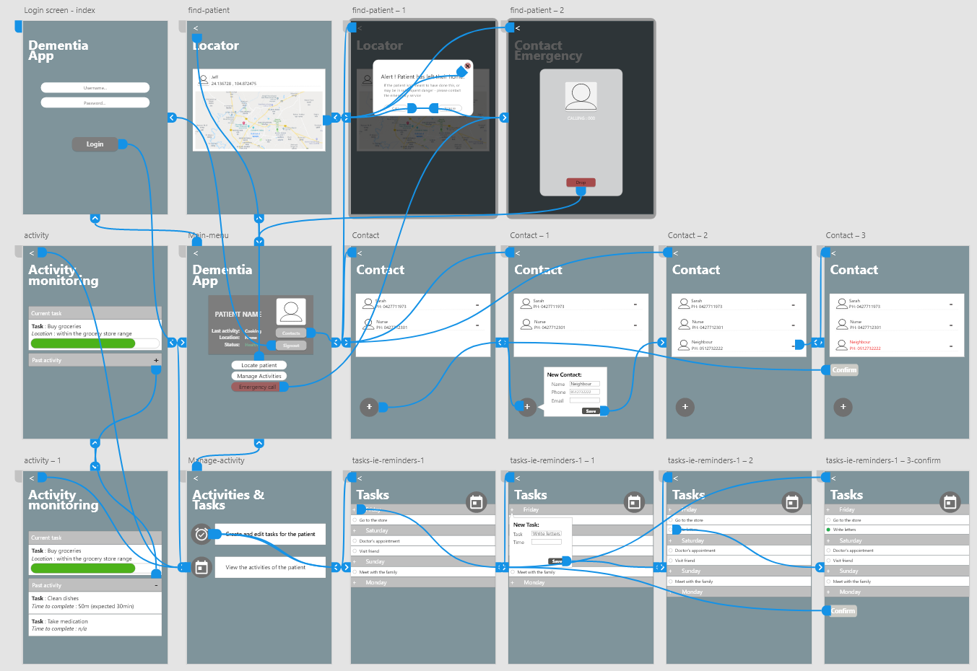

## 2.1 Secure login

Important non-functional requirement [this page links directly to the main ‘home’ page] 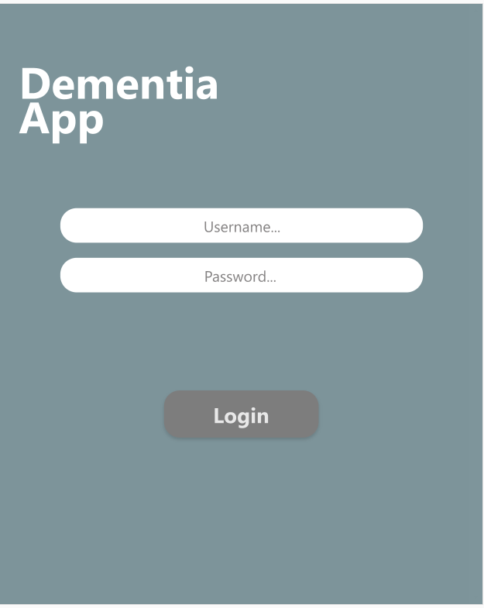

## 3.1 Home page

Main page of the solution, provides the user with access to the main functional requirements the caregiver would need to check on the activity and location of the PwD.  
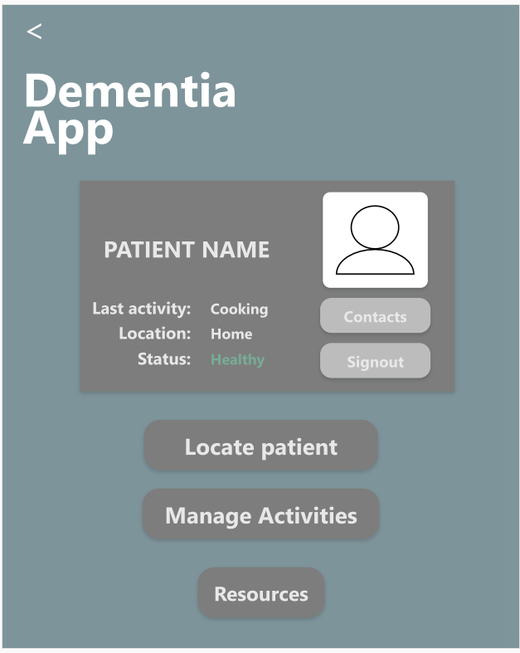

## 4.1 Locator

(**1**) Location finder for the PwD, the ultimate functional-requirement for the solution  
(**2**) Popup message (which is sent once the patient has left their home) that   
(**3**) queries the user to either call emergency services or ignore.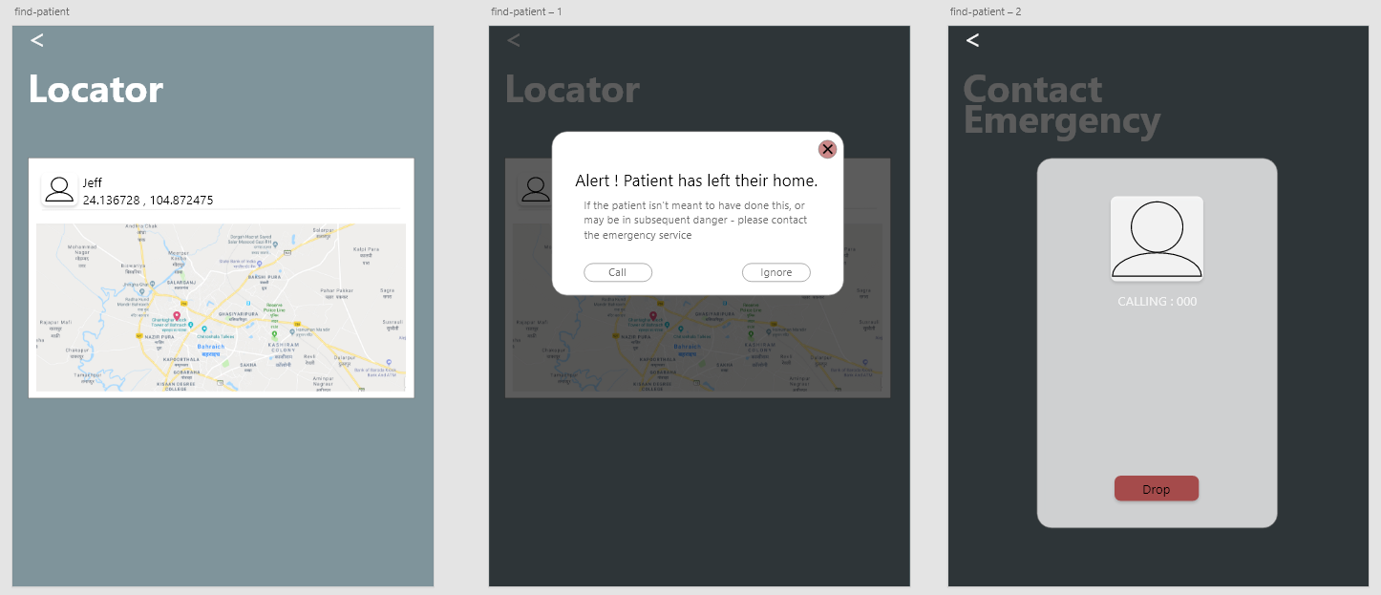

## 5 - Activity overview

Activity/task management page

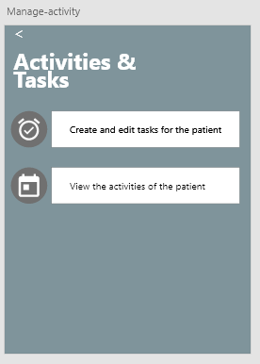

## 5.1 Activity monitoring

UI element that shows the progress from the tasks beginning to it’s current (anticipated) stage, enables cleared understanding of the tasks currently being done by the PwD.

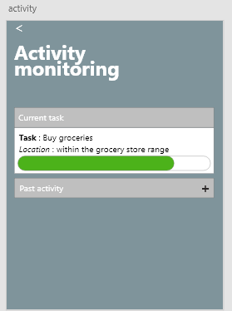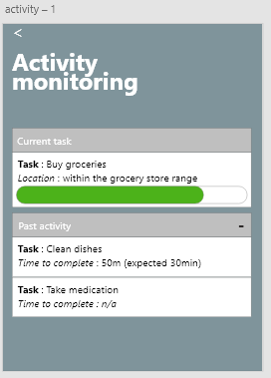

## 5.2 Task management

Create and push tasks to the end-user (PwD), this in tandem with the aforementioned (5.1) feature will allow for clear micromanaging of tasks for the caregiver.

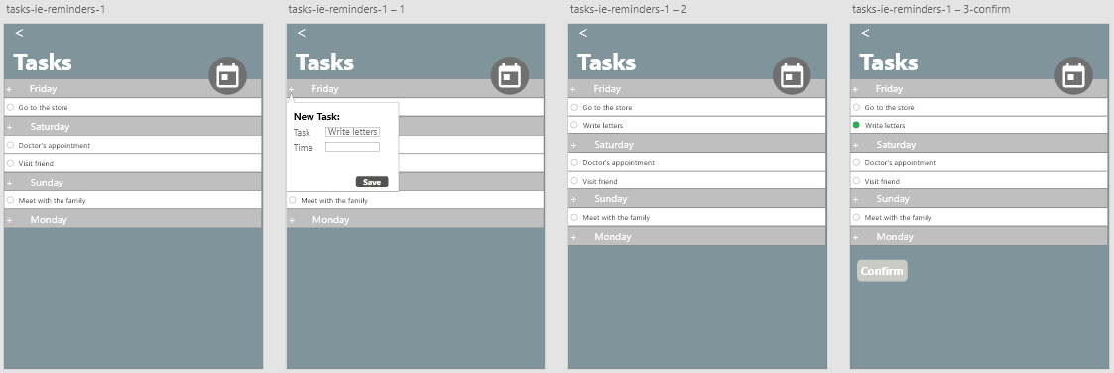

## 6.1 Contact management

Allows the primary user to manage the contacts available to the PwD [in case of emergency].

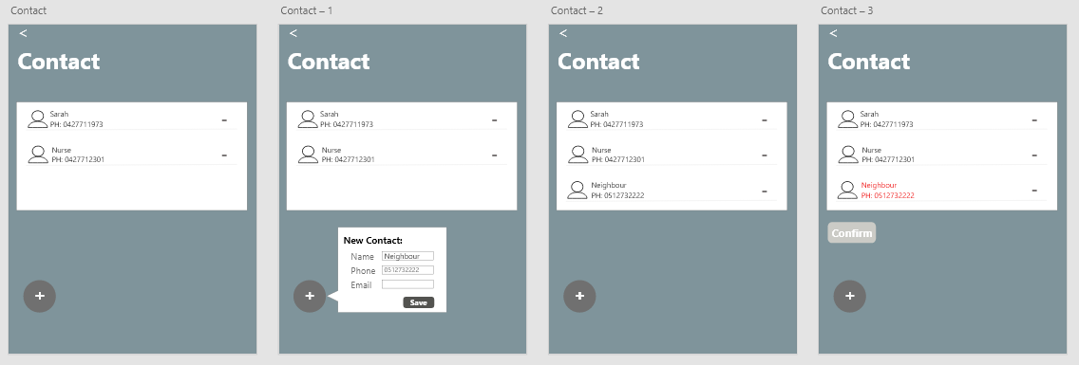

Glossary:

* PwD – acronym for “Patient with dementia”;